How to Manage Docker Containers using Portainer on Ubuntu

On this page
- Prerequisites
- What we will do
- Step 1 - Install Docker on Ubuntu 16.04 LTS
- Step 2 - Install and Configure Portainer
- Step 3 - Deploy New App Container
- Step 4 - Manage Docker Environment Using Portainer
  - Manage Containers
  - Manage Docker Images
  - Manage Networks
  - Manage Volumes
- Reference

Portainer is an open-source management UI for Docker, including Docker Swarm environment. Portainer makes it easier for you to manage your Docker containers, it allows you to manage containers, images, networks, and volumes from the web-based Portainer dashboard.
In this tutorial, I will show you step-by-step how to install and configure Portainer on Ubuntu 16.04 LTS. We will install and configure Portainer, deploy the Apps Container, Manage Container, images, network, and volumes for our Docker environment.

Prerequisites
- Ubuntu Server
- Root privileges

What we will do
- Install Docker on Ubuntu
- Install and Configure Portainer
- Deploy Ghost Blog App Container
- Docker Environment Management

Step 1 - Install Docker on uServer

Update & Upgrade
sudo apt update && sudo apt upgrade -y;

Install docker
sudo apt install docker.io docker-compose -y;

Add user to docker group
sudo usermod -aG docker cvandemberg;
sudo usermod -aG docker is_derayo;

Start & Enable docker
sudo systemctl start docker;
sudo systemctl enable docker;
systemctl status docker.service;

systemctl list-unit-files | grep docker;
sudo docker ps -a

Goto :Step 1.b

If start fails:
sudo systemctl unmask docker.service;
sudo systemctl unmask docker.socket;
sudo systemctl start docker.service;

systemctl list-unit-files | grep docker;
sudo docker ps -a;

Error starting daemon: error initializing graphdriver: /var/lib/docker contains several valid graphdrive
sudo touch /etc/docker/daemon.json
sudo vim /etc/docker/daemon.json
{
"storage-driver": "overlay"
}

╭── # root@uServerOffice /etc/docker :
╰─▷ $ cat /etc/docker/daemon.json
{
"storage-driver": "overlay"
}

Check docker’s status:
systemctl status docker.service;

:Step 1 .b
Docker installed on ubuntu 16.04 server, check it using the command below.
sudo docker version;

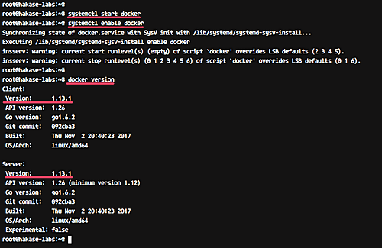

Step 2 - Install and Configure Portainer

Portainer can be installed as a docker container like in this case and standalone without docker container.
Before installing Portainer, download the Portainer image from the DockerHub.

sudo docker pull portainer/portainer;
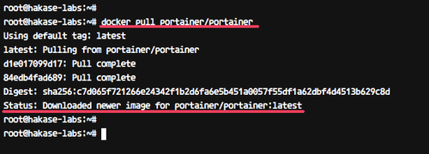
Now run Portainer using the simple docker command below
sudo docker volume create portainer_data;
sudo docker run -d -p 9000:9000 --restart always --name portainer -v \
/var/run/docker.sock:/var/run/docker.sock -v portainer_data:/data portainer/portainer;

Portainer is now running as a container, check it using the docker ps command
sudo docker ps;
sudo docker ps -a;

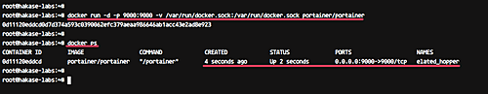

Portainer is now running as a Docker container with the name 'elatted_hopper', and it's running under port 9000.
Next, we will configure the Admin password for the Portainer.
Open your web browser and type the server IP address with port 9000.
http://192.168.1.100:9000/
http://192.168.122.240:9000/

You will get the page about the admin user and password configuration.

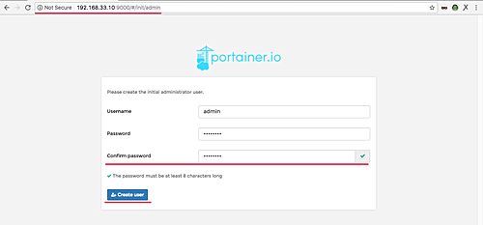

Type your strong admin password and click the 'Create user' button.
Now we need to define which environment Portainer will connect. Portainer offers support for standalone Docker environment, Docker Swarm, and Swarm mode.
For this guide, we will configure Portainer to connect to the local Docker environment.

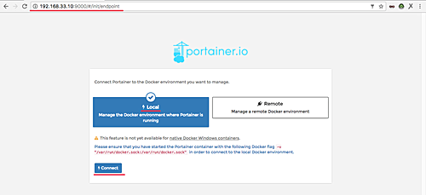

Choose the 'Local' environment and click 'Connect' button.
And now you will see the Portainer Admin Dashboard.
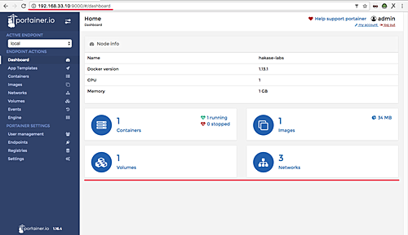
Portainer has been installed as a Docker Container on Ubuntu 16.04.

Step 3 - Deploy New App Container

After the Portianer installation, we will run the Application Container using Portainer.
Click the 'App Template' menu.
Now choose the application that you want to install. For this guide, we will install the 'Ghost' blog as a Docker Container.
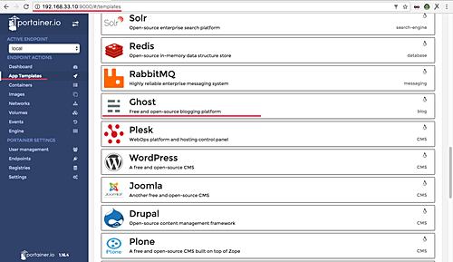

Click 'Ghost'.
Type the container name ghost-blog and click the 'Show advanced options'. On the 'Port mapping' configuration, type port 82 on the 'host'.
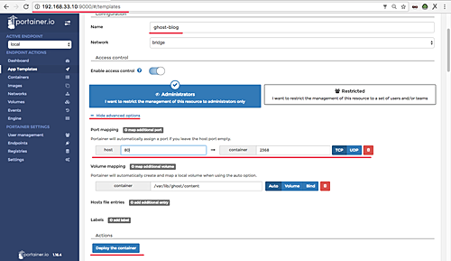

Now click 'Deploy the container' button.
And when it's complete, you will get the container page as below.

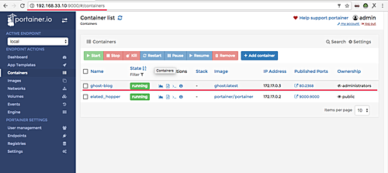
Ghost is now installed as a Docker Container and it's using port 82 on the host.

Open your web browser and type the server IP address.
http://192.168.1.100:82
http://192.168.122.240:82

And you will get the 'Ghost' blog homepage as below.



Step 4 - Manage Docker Environment Using Portainer
In this step, we will configure Docker Environments such as Docker images, Container, Volumes, and Networks.

Manage Containers
Portainer provides a simple and easy way to use management for Docker Containers.
Click the 'Containers' menu on the left and you will get the page as below.

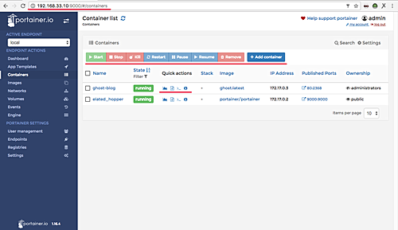

We can start, stop, restart, create a new container, access the shell of the container, see the container log, and stats of the container from this Portainer container management.
Shell of the Ghost container:
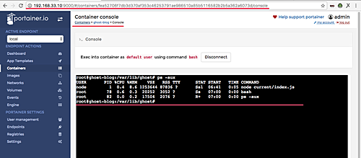

Ghost container logs:
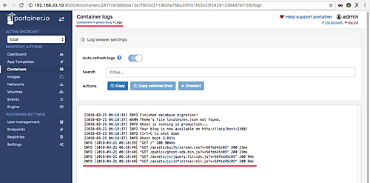

The container stats:
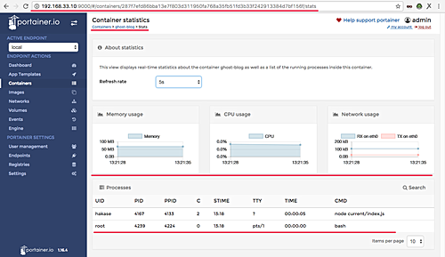

Manage Docker Images
Click the 'Images' menu and you will get the page as below.
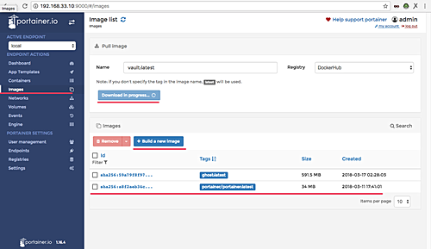
Now we can see the list of docker images on our system, and we can create manually a new docker image, or pull/download new images from the DockerHub repository.

Manage Networks
From this menu, we create new custom networks for our Docker environment. Click the 'Networks' menu.
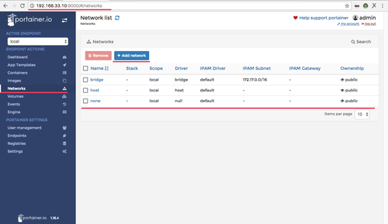

Manage Volumes
This menu provides an easy way to create new custom volumes for our container.
We just need to create new custom volumes, and when we want to create new container the application, just attach it to the container through the 'Advanced options' menu.
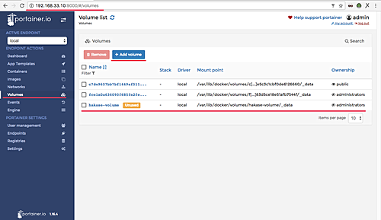
Installation and configuration of the Portainer Docker Management UI on Ubuntu 16.04 has been completed successfully.

