How to install NextCloud on Ubuntu

https://www.marksei.com/how-to-install-nextcloud-12-on-ubuntu/

How to install NextCloud 12 on Ubuntu

17.10


NextCloud is a Dropbox-like solution for self-hosted file sharing and syncing. Installing NextCloud 12 on Ubuntu is trivial. Whether you want to backup, have file-syncing or just have a Google Calendar alternative, this guide is for you.

What is NextCloud? Is it like a “cloud”?
If you stumbled here by chance and don’t know what NextCloud is, here is an article explaining its principal features and advantages/disadvantages. In this other article you can find NextCloud 12 new features. To tell you the truth, NextCloud is a SaaS cloud, if you want to know more about cloud types you can read this article.
In this article we will cover the installation of the server (not the client).

Step1: Install software
Important
I take absolutely NO responsibility of what you do with your machine; use this tutorial as a guide and remember you can possibly cause data loss if you touch things carelessly.
The first step in order to install NextCloud 12 is to install a web server and PHP. Although you can adapt this guide for many Ubuntu versions I suggest you to stick with Ubuntu 16.04 or higher since PHP7 is included. PHP7 brings many improvements over the past versions and will boost NextCloud too, as a matter of fact PHP7 is required since NextCloud 11. You will need root access during this procedure. The following procedure will install apache as webserver. Input the commands one by one to avoid errors!

Ubuntu 17.10
Open terminal
apt-get install apache2 libapache2-mod-php7.0 bzip2
apt-get install php7.0-gd php7.0-json php7.0-mysql php7.0-curl php7.0-mbstring
apt-get install php7.0-intl php7.0-mcrypt php-imagick php7.0-xml php7.0-zip

Step2: Database selection
Now that you have set up the environment, all that is left is to choose a database that will support the installation. You have three choices:
- SQLite: is a single-file database. It is suggested only for small installations since it will slow NextCloud down sensibly.
- MariaDB/MySQL: are popular open source databases especially amongst web developers. It is the suggested choice.
- PostgreSQL: a popular enterprise-class database. More complicated than MySQL/MariaDB.
Now, this choice won’t really alter the functionality of NextCloud (except if you use SQLite), so pick whatever you know best. If you’re unsure pick MariaDB/MySQL.

SQLite
apt-get install sqlite3 php-sqlite3

MariaDB
apt-get install mariadb-server php-mysql

MySQL
apt-get install mysql-server php-mysql

During the installation you will be prompted to choose a root password, pick a strong one. If you’re not prompted to choose a password, the default one will be blank. (This is potentially insecure, change it!)
Now you need to enter the database (you will be asked the password you just set):
mysql -u root -p
CREATE DATABASE nextcloud;
CREATE USER 'nc_user'@'localhost' IDENTIFIED BY 'YOUR_PASSWORD_HERE';
GRANT ALL PRIVILEGES ON nextcloud.* TO 'nc_user'@'localhost';
FLUSH PRIVILEGES;

PostgreSQL
apt-get install postgresql php-pgsql
sudo -u postgres psql
CREATE DATABASE nextcloud;
CREATE USER nc_user WITH PASSWORD 'YOUR_PASSWORD_HERE';
GRANT ALL PRIVILEGES ON DATABASE nextcloud to nc_user;
\q

Step 3: Install NextCloud

The last step is to actually get the software, configure it and run it.

Ubuntu

cd /var/www

wget https://download.nextcloud.com/server/releases/latest-12.tar.bz2 -O nextcloud-12-latest.tar.bz2

tar -xvjf nextcloud-12-latest.tar.bz2
chown -R www-data:www-data nextcloud
rm nextcloud-12-latest.tar.bz2

Now we need to create a new file in /etc/apache2/sites-available/nextcloud.conf . Feel free to use whatever editor you feel comfortable with and add the following lines:

Alias /nextcloud "/var/www/nextcloud/"

<Directory /var/www/nextcloud/>
Options +FollowSymlinks
AllowOverride All

<IfModule mod_dav.c>
Dav off
</IfModule>

SetEnv HOME /var/www/nextcloud
SetEnv HTTP_HOME /var/www/nextcloud

</Directory>

Once done it’s time to enable the new site and enable apache mods that are needed by NextCloud:

a2ensite nextcloud
a2enmod rewrite headers env dir mime
systemctl restart apache2

Step 4: Configuring firewall

This step is essential when your firewall is enabled. If your firewall is enabled you won’t be able to access your NextCloud 12 instance; on the other hand if it isn’t enabled you shouldn’t have any problems and you can simply skip this step.

Tip!
Keep in mind having a firewall enabled is a good security practice and you should already have one enabled.

In order for the firewall to work, it must be enabled. This guide will not include this part. When you enable a firewall many things can go wrong, e.g. you’re using SSH, you enable the firewall and your connection is cut and can’t connect otherwise, hence you should carefully review the documentation from your distribution.

To open the ports needed by NextCloud 12 follow these steps:

UFW

UFW is the default firewall in Ubuntu, if you’re using one, you’re probably using UFW.

ufw allow http
ufw allow https

IPtables

IPtables is an older firewall (still widely used), if you’re not using UFW you can use IPtables directly.

iptables -A INPUT -p tcp -m tcp --dport 80 -j ACCEPT
iptables -A INPUT -p tcp -m tcp --dport 443 -j ACCEPT

Step 5: Install

Once you’re done with selecting the database, it’s time to install everything. Head to http://YOUR_IP_ADDRESS/nextcloud/ and you will be facing the following screen:

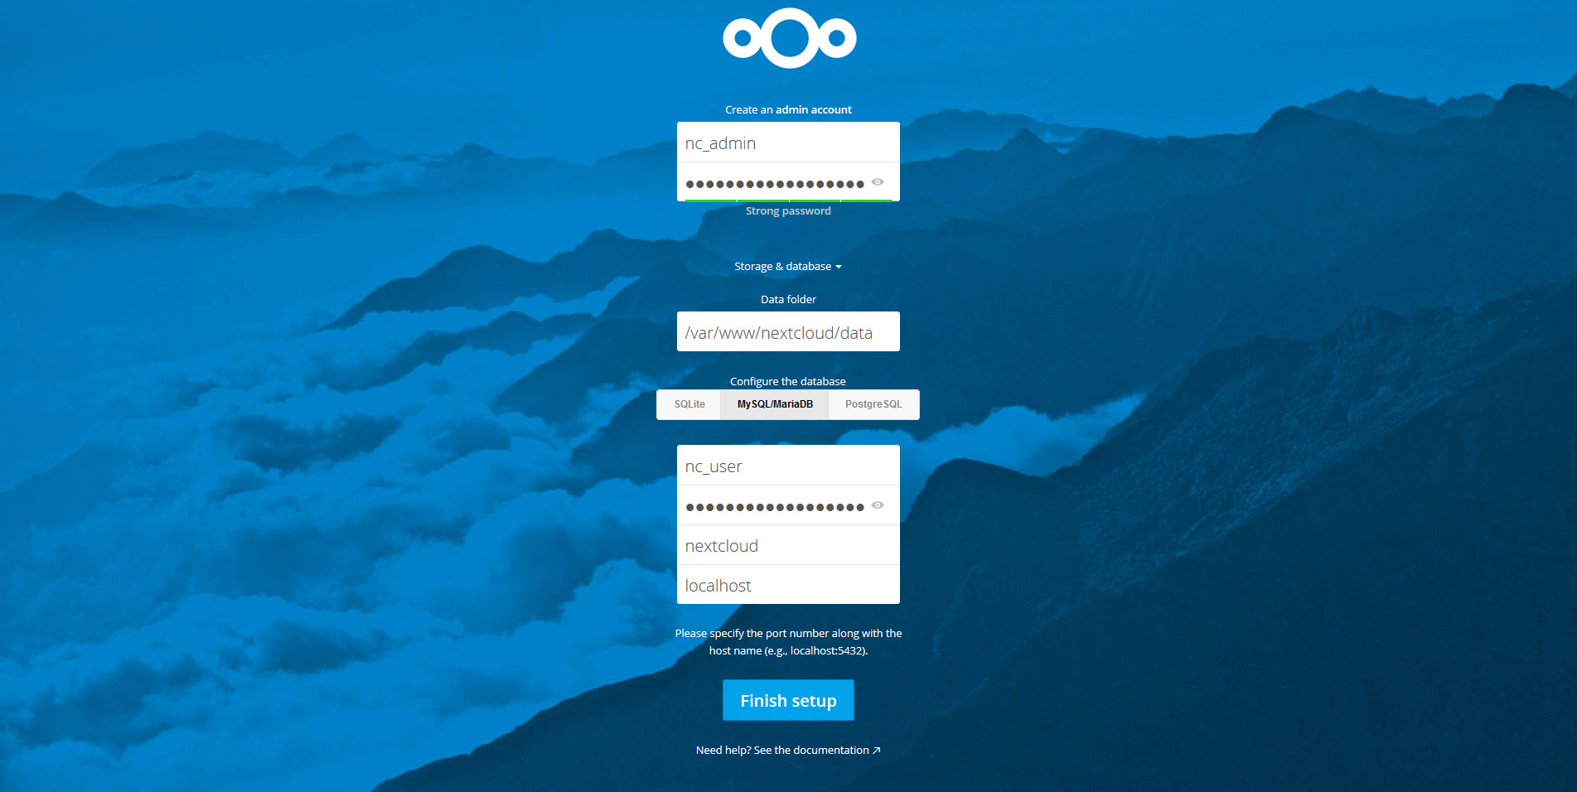

Select an administrator username and password, then you can select the data folder, but if you don’t know what you’re doing it’s best if you leave it with the default value. Then click on “Storage & Database” to select the database you chose during step 2. Fill everything and if you’ve followed all the steps correctly you should be seeing the Files app:



