tecmint.com

10 Practical Examples of Rsync Command in Linux

Rsync (Remote Sync) is the most commonly used command for copying and synchronizing files and directories remotely as well as locally in Linux/Unix systems.
With the help of the rsync command, you can copy and synchronize your data remotely and locally across directories, disks, and networks, perform data backups, and mirror between two Linux machines.

This article explains 10 basic and advanced usage of the rsync command to transfer your files remotely and locally in Linux-based machines. You don’t need to be a root user to run the rsync command.

Some Advantages and Features of Rsync Command
- It efficiently copies and sync files to or from a remote system.
- Supports copying links, devices, owners, groups, and permissions.
- It’s faster than scp (Secure Copy) because rsync uses a remote-update protocol which allows transferring just the differences between two sets of files. The first time, it copies the whole content of a file or a directory from source to destination but from next time, it copies only the changed blocks and bytes to the destination.
- Rsync consumes less bandwidth utilization as it uses compression and decompression method while sending and receiving data on both ends.

The basic syntax of the rsync command
# rsync options source destination

Some common options used with rsync commands
- -v : verbose
- -r : copies data recursively (but don’t preserve timestamps and permission while transferring data.
- -a : archive mode, which allows copying files recursively and it also preserves symbolic links, file permissions, user & group ownerships, and timestamps.
- -z : compress file data.
- -h : human-readable, output numbers in a human-readable format.
[ You might also like: How to Sync Files/Directories Using Rsync with Non-standard SSH Port ]

Install Rsync in Linux System
We can install the rsync package with the help of the following command in your Linux distribution.
$ sudo apt-get install rsync [On Debian/Ubuntu & Mint]
$ pacman -S rsync [On Arch Linux]
$ emerge sys-apps/rsync [On Gentoo]
$ sudo dnf install rsync [On Fedora/CentOS/RHEL and Rocky Linux/AlmaLinux]
$ sudo zypper install rsync [On openSUSE]

1. Copy/Sync Files and Directory Locally
The following command will sync a single file on a local machine from one location to another location. Here in this example, a file name backup.tar needs to be copied or synced to /tmp/backups/ folder.
[root@tecmint]# rsync -zvh backup.tar.gz /tmp/backups/

created directory /tmp/backups
backup.tar.gz

sent 224.54K bytes received 70 bytes 449.21K bytes/sec
total size is 224.40K speedup is 1.00
In the above example, you can see that if the destination is not already existed rsync will create a directory automatically for the destination.
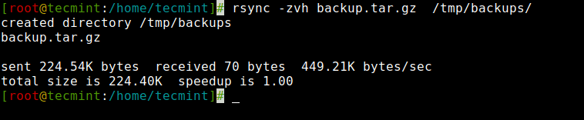

Copy/Sync a Directory on Local Computer
The following command will transfer or sync all the files from one directory to a different directory in the same machine. Here in this example, /root/rpmpkgs contains some rpm package files and you want that directory to be copied inside /tmp/backups/ folder.
[root@tecmint]# rsync -avzh /root/rpmpkgs /tmp/backups/

sending incremental file list
rpmpkgs/
rpmpkgs/httpd-2.4.37-40.module_el8.5.0+852+0aafc63b.x86_64.rpm
rpmpkgs/mod_ssl-2.4.37-40.module_el8.5.0+852+0aafc63b.x86_64.rpm
rpmpkgs/nagios-4.4.6-4.el8.x86_64.rpm
rpmpkgs/nagios-plugins-2.3.3-5.el8.x86_64.rpm

sent 3.47M bytes received 96 bytes 2.32M bytes/sec
total size is 3.74M speedup is 1.08
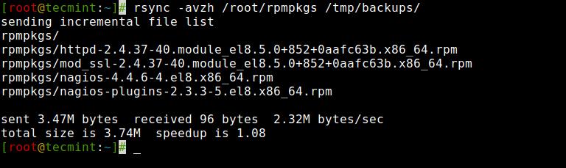

2. Copy/Sync Files and Directory to or From a Server
This command will sync a directory from a local machine to a remote machine. For example, there is a folder in your local computer “rpmpkgs” that contains some RPM packages and you want that local directory’s content sends to a remote server, you can use the following command.
[root@tecmint:~]# rsync -avzh /root/rpmpkgs root@192.168.0.141:/root/

The authenticity of host '192.168.0.141 (192.168.0.141)' can't be established.
ED25519 key fingerprint is SHA256:bH2tiWQn4S5o6qmZhmtXcBROV5TU5H4t2C42QDEMx1c.
This key is not known by any other names
Are you sure you want to continue connecting (yes/no/[fingerprint])? yes
Warning: Permanently added '192.168.0.141' (ED25519) to the list of known hosts.
root@192.168.0.141's password:
sending incremental file list
rpmpkgs/
rpmpkgs/httpd-2.4.37-40.module_el8.5.0+852+0aafc63b.x86_64.rpm
rpmpkgs/mod_ssl-2.4.37-40.module_el8.5.0+852+0aafc63b.x86_64.rpm
rpmpkgs/nagios-4.4.6-4.el8.x86_64.rpm
rpmpkgs/nagios-plugins-2.3.3-5.el8.x86_64.rpm

sent 3.74M bytes received 96 bytes 439.88K bytes/sec
total size is 3.74M speedup is 1.0
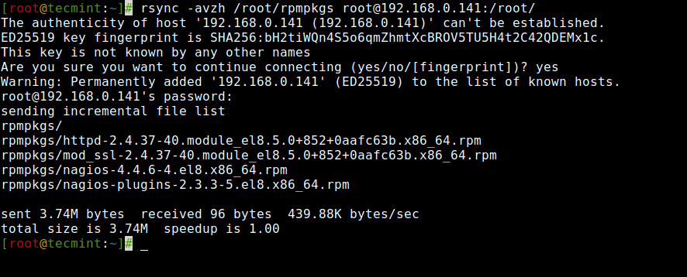

Copy/Sync a Remote Directory to a Local Machine
This command will help you sync a remote directory to a local directory. Here in this example, a directory /root/rpmpkgs which is on a remote server is being copied in your local computer in /tmp/myrpms.
[root@tecmint:~]# rsync -avzh root@192.168.0.141:/root/rpmpkgs /tmp/myrpms

root@192.168.0.141's password:
receiving incremental file list
created directory /tmp/myrpms
rpmpkgs/
rpmpkgs/httpd-2.4.37-40.module_el8.5.0+852+0aafc63b.x86_64.rpm
rpmpkgs/mod_ssl-2.4.37-40.module_el8.5.0+852+0aafc63b.x86_64.rpm
rpmpkgs/nagios-4.4.6-4.el8.x86_64.rpm
rpmpkgs/nagios-plugins-2.3.3-5.el8.x86_64.rpm

sent 104 bytes received 3.49M bytes 997.68K bytes/sec
total size is 3.74M speedup is 1.07
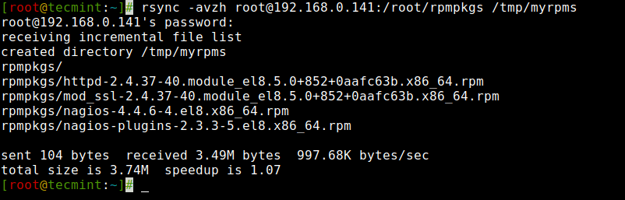

3. Rsync Over SSH
With rsync, we can use SSH (Secure Shell) for data transfer, using SSH protocol while transferring our data you can be ensured that your data is being transferred in a secured connection with encryption so that nobody can read your data while it is being transferred over the wire on the internet.
[ You might also like: How to Secure and Harden OpenSSH Server ]
Also when we use rsync we need to provide the user/root password to accomplish that particular task, so using the SSH option will send your logins in an encrypted manner so that your password will be safe.

Copy a File from a Remote Server to a Local Server with SSH
To specify a protocol with rsync you need to give the “-e” option with the protocol name you want to use. Here in this example, We will be using the “ssh” with the “-e” option and perform data transfer.
[root@tecmint:~]# rsync -avzhe ssh root@192.168.0.141:/root/anaconda-ks.cfg /tmp

root@192.168.0.141's password:
receiving incremental file list
anaconda-ks.cfg

sent 43 bytes received 1.10K bytes 325.43 bytes/sec
total size is 1.90K speedup is 1.67
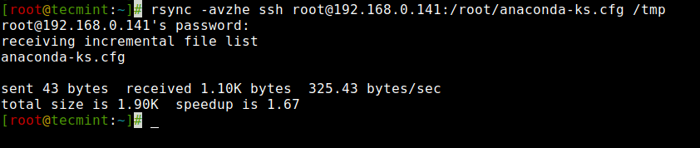

Copy a File from a Local Server to a Remote Server with SSH
[root@tecmint:~]# rsync -avzhe ssh backup.tar.gz root@192.168.0.141:/backups/

root@192.168.0.141's password:
sending incremental file list
created directory /backups
backup.tar.gz

sent 224.59K bytes received 66 bytes 64.19K bytes/sec
total size is 224.40K speedup is 1.00
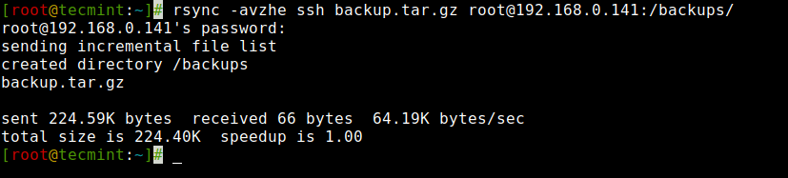
[ You might also like: How to Use Rsync to Sync New or Changed/Modified Files in Linux ]

4. Show Progress While Transferring Data with rsync
To show the progress while transferring the data from one machine to a different machine, we can use the ‘–progress’ option. It displays the files and the time remaining to complete the transfer.
[root@tecmint:/]# rsync -avzhe ssh --progress /root/rpmpkgs root@192.168.0.141:/root/rpmpkgs

root@192.168.0.141's password:
sending incremental file list
rpmpkgs/
rpmpkgs/httpd-2.4.37-40.module_el8.5.0+852+0aafc63b.x86_64.rpm
1.47M 100% 31.80MB/s 0:00:00 (xfr#1, to-chk=3/5)
rpmpkgs/mod_ssl-2.4.37-40.module_el8.5.0+852+0aafc63b.x86_64.rpm
138.01K 100% 2.69MB/s 0:00:00 (xfr#2, to-chk=2/5)
rpmpkgs/nagios-4.4.6-4.el8.x86_64.rpm
2.01M 100% 18.45MB/s 0:00:00 (xfr#3, to-chk=1/5)
rpmpkgs/nagios-plugins-2.3.3-5.el8.x86_64.rpm
120.48K 100% 1.04MB/s 0:00:00 (xfr#4, to-chk=0/5)

sent 3.74M bytes received 96 bytes 1.50M bytes/sec
total size is 3.74M speedup is 1.00
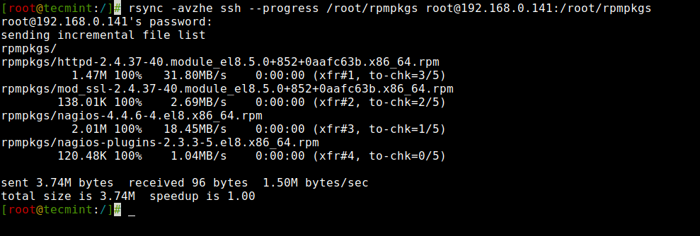

5. Use of –include and –exclude Options
These two options allow us to include and exclude files by specifying parameters with these option helps us to specify those files or directories which you want to include in your sync and exclude files and folders with you don’t want to be transferred.
Here in this example, the rsync command will include those files and directory only which starts with ‘R’ and exclude all other files and directory.
[root@tecmint:/]# rsync -avze ssh --include 'R*' --exclude '*' root@192.168.0.141:/var/lib/rpm/ /root/rpm

root@192.168.0.141's password:
receiving incremental file list
created directory /root/rpm
./
Requirename

sent 61 bytes received 273,074 bytes 60,696.67 bytes/sec
total size is 761,856 speedup is 2.79

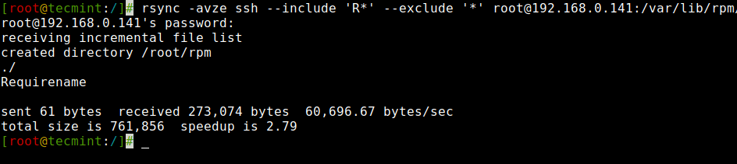

6. Use of –delete Option
If a file or directory does not exist at the source, but already exists at the destination, you might want to delete that existing file/directory at the target while syncing.
We can use the ‘–delete‘ option to delete files that are not there in the source directory.
Source and target are in sync. Now create a new file test.txt at the target.
[root@tecmint:~]# cd /root/rpm/
[root@tecmint:~/rpm]# touch test.txt
[root@tecmint:~/rpm]# rsync -avz --delete root@192.168.0.151:/var/lib/rpm/ /root/rpm/

root@192.168.0.151's password:
receiving incremental file list
deleting test.txt
./
.dbenv.lock
.rpm.lock
Basenames
Conflictname
Dirnames
Enhancename
Filetriggername
Group
Installtid
Name
Obsoletename
Packages
Providename
Sha1header
Sigmd5
Suggestname
Supplementname
Transfiletriggername
Triggername
__db.001
__db.002
__db.003

sent 445 bytes received 18,543,954 bytes 2,472,586.53 bytes/sec
total size is 71,151,616 speedup is 3.84
Target has the new file called test.txt, when synchronizing with the source with the ‘–delete‘ option, it removed the file test.txt.
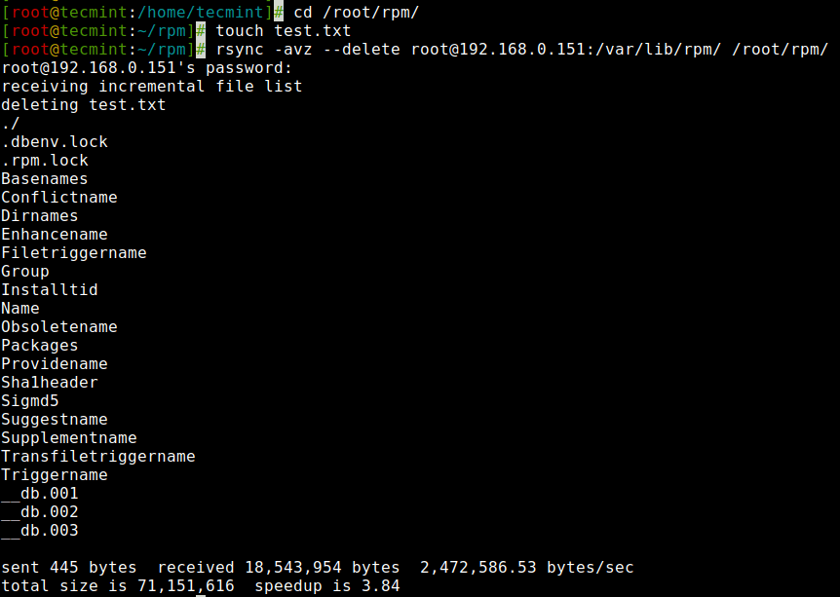

7. Set the Max Size of Files to be Transferred
You can specify the Max file size to be transferred or sync. You can do it with the “–max-size” option. Here in this example, the Max file size is 200k, so this command will transfer only those files which are equal to or smaller than 200k.
[root@tecmint:~]# rsync -avzhe ssh --max-size='200k' /var/lib/rpm/ root@192.168.0.151:/root/tmprpm

root@192.168.0.151's password:
sending incremental file list
created directory /root/tmprpm
./
.dbenv.lock
.rpm.lock
Conflictname
Enhancename
Filetriggername
Group
Installtid
Name
Obsoletename
Recommendname
Requirename
Sha1header
Sigmd5
Suggestname
Supplementname
Transfiletriggername
Triggername
__db.002

sent 129.52K bytes received 396 bytes 28.87K bytes/sec
total size is 71.15M speedup is 547.66
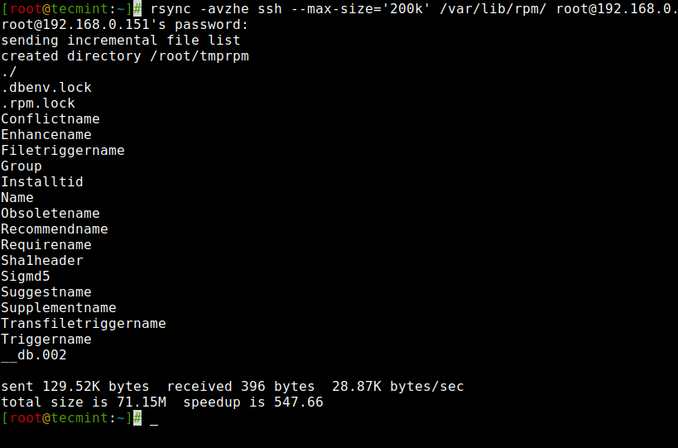

8. Automatically Delete source Files After Successful Transfer
Now, suppose you have the main web server and a data backup server, you created a daily backup and synced it with your backup server, now you don’t want to keep that local copy of backup in your web server.
So, will you wait for the transfer to complete and then delete that local backup file manually? Of Course NO. This automatic deletion can be done using the ‘–remove-source-files‘ option.
[root@tecmint:~]# rsync --remove-source-files -zvh backup.tar.gz root@192.168.0.151:/tmp/backups/

root@192.168.0.151's password:
backup.tar.gz

sent 795 bytes received 2.33K bytes 894.29 bytes/sec
total size is 267.30K speedup is 85.40

[root@tecmint:~]# ls -l backup.tar.gz

ls: cannot access 'backup.tar.gz': No such file or directory
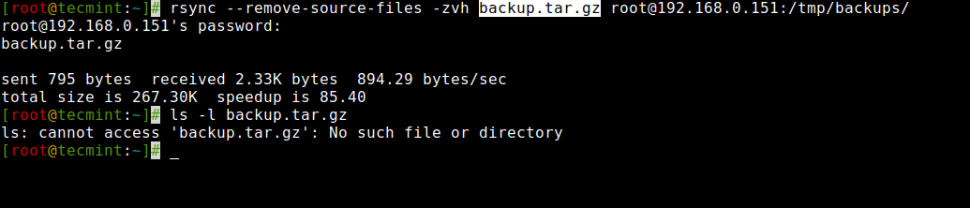

9. Do a Dry Run with rsync
If you are a newbie using rsync and don’t know what exactly your command going to do. Rsync could really mess up the things in your destination folder and then doing an undo can be a tedious job.
[ You might also like: How to Sync Two Apache Web Servers/Websites Using Rsync ]
Use of this option will not make any changes to the files and shows the output of the command, if the output shows exactly the same you want to do then you can remove the ‘–dry-run‘ option from your command and run on the terminal.
[root@tecmint:~]# rsync --dry-run --remove-source-files -zvh backup.tar.gz root@192.168.0.151:/tmp/backups/

root@192.168.0.151's password:
backup.tar.gz

sent 50 bytes received 19 bytes 19.71 bytes/sec
total size is 267.30K speedup is 3,873.97 (DRY RUN)
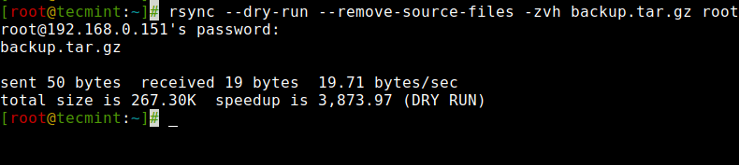

10. Rsync Set Bandwidth Limit and Transfer File
You can set the bandwidth limit while transferring data from one machine to another machine with the the help of ‘–bwlimit‘ option. This option helps us to limit I/O bandwidth.
[root@tecmint]# rsync --bwlimit=100 -avzhe ssh /var/lib/rpm/ root@192.168.0.151:/root/tmprpm/
root@192.168.0.151's password:
sending incremental file list
sent 324 bytes received 12 bytes 61.09 bytes/sec
total size is 38.08M speedup is 113347.05
Also, by default rsync syncs changed blocks and bytes only, if you want explicitly want to sync the whole file then you use the ‘-W‘ option with it.
[root@tecmint]# rsync -zvhW backup.tar /tmp/backups/backup.tar
backup.tar
sent 14.71M bytes received 31 bytes 3.27M bytes/sec
total size is 16.18M speedup is 1.10
That’s all with rsync now, you can see man pages for more options. Stay connected with Tecmint for more exciting and interesting tutorials in the future. Do leave your comments and suggestions.

