websiteforstudents.com

Create a Public Samba Share on Ubuntu 17.04 / 17.10 – Website for Students
This brief tutorial shows students and new users how to create a public Samba shares on Ubuntu server so everyone can access without authenticating. This share will be fully accessible to all and everyone will be able create, modify and delete folders and files.
Then in our next post we’ll show you how to create restricted shares so only authenticated users can access.
For those who don’t know, Samba is a opensource implementation of Microsoft SMB/CIFS protocol. It provides fast and secure files and print services for clients using the SMB/CIFS protocol. Simply put, it provides files and printer sharing between clients and servers.
To get started with creating a public share that can be fully accessed by everyone, continue with the steps below:

Step 1: Install Samba
The first thing you’ll need to do is install Samba. To install it run the commands below.
sudo apt-get update
sudo apt-get install samba
The commands above install Samba and all other dependencies.

Step 2: Create the Share
First, create the folder you want to share with the public. The folder can be anywhere but set its permission so that everyone can access it. For this this tutorial, our share will be /home/Public
Run the commands below to create the folder you wish to share.
sudo mkdir /home/Public
Then set the share permission so everyone has full access to it.
sudo chmod 0777 /home/Public
sudo chown -R nobody:nogroup /home/Public

Step 3: Configure Samba
Now that Samba is installed, you must now configure it to provide file and print services to clients. This can be done by editing its default configurations file. First create a backup of the configuration file by running the commands below.
sudo mv /etc/samba/smb.conf /etc/samba/smb.conf.bak
Next, run the commands below to open/create a new configuration file.
sudo nano /etc/samba/smb.conf
Then add the content below into the file and save. Our share will be called Public as defined in the setting below [Public]
[global]
workgroup = WORKGROUP
server string = Samba Server %v
netbios name = ubuntu
security = user
map to guest = bad user
name resolve order = bcast host
dns proxy = no
bind interfaces only = yes

# add to the end
[Public]
path = /home/Public
writable = yes
guest ok = yes
guest only = yes
read only = no
create mode = 0777
directory mode = 0777
force user = nobody
Save the file and exit

Step 4: Restart Samba
After configuring the setting above, restart Samba by running the commands below.
sudo systemctl restart smbd

Step 5: Access the Share
Now log on to your other computers and access or map the share using the Ubuntu machine name or IP address.
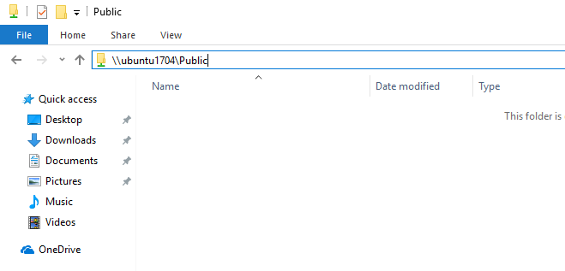

You can map the location if you’d like
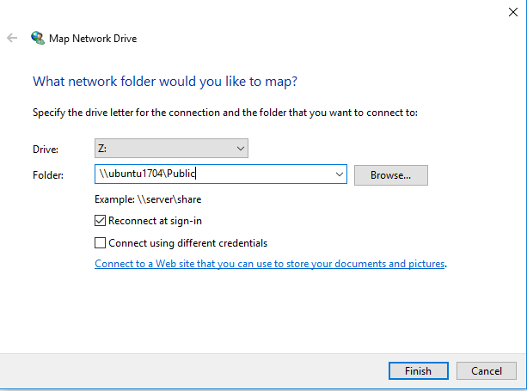
Enjoy!
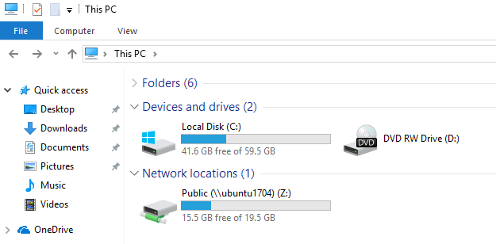

You may also like the post below:
Setup OpenSSH Password Authentication on Ubuntu 17.04 / 17.10

About The Author

!robot
This post was not created by a robot! My name is Richard and spend my spare time searching for ways to help students and new users get to know and understand Linux, Ubuntu, Windows, and Open Source software.I try to write every article as simple-to-understand as possible so anyone can easily follow. This site is dedicated to IT students and new users who want to learn about these subjects. Thanks!

